Ansible Projects

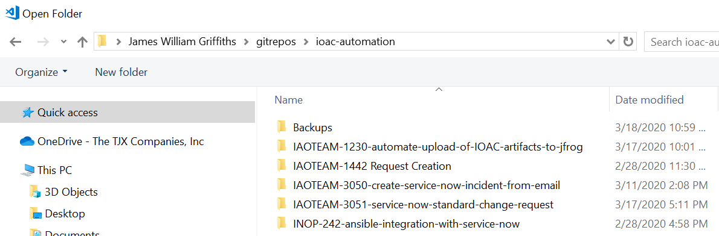

**Feature branches on Bitbucket**

